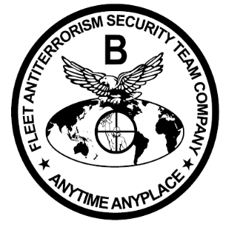

Bravo Fleet Antiterrorism Security Team Company

Welcome to Bravo FAST Company. We are located at 686 Ballard Road Yorktown, Va 23691. Our mission is to conduct rapid response expeditionary antiterrorism and security operations in order to protect vital national and naval assets. Our company is comprised of six FAST Platoons of 50 men each designed to deploy within 6 hours to provide immediate security to a designated crisis site. Our history dates back to 1987 and we collectively have carried out security missions in Saudi Arabia, Panama, Bahrain, Yemen, Iraq, Horn of Africa, Egypt, Azerbaijan, Philippines, in addition to various US Naval and foreign naval vessels. You can expect to train independently as platoons throughout the greater Virginia and North Carolina area and further deploy to Spain, Bahrain, Japan, and Cuba. This will be one of your greatest experiences in the Marine Corps and an awesome opportunity to build your platoon tailored to your vision as a leader.

Please reach out to the following personnel to assist with your reception and to answer any questions:

Officers:
Company XO 757-887-4457

SNCOs/NCOs:
Company 1stSgt 757-637-9342
Company Operations Chief 757-637-9199
Company GySgt 757-637-9196

Semper Fidelis
CO Bravo Company

